Design Document v2

Watcher

Created by Nicholas Evans, 3517231
Class: MAAC3601 – Game Design I
Professor: Jeff Mundee
University of New Brunswick
Monday, November 3rd, 2020

Overview

Log Line
The player is an analyst, stuck behind a computer, for an agency that watches a city's population through cameras and interception of communications. The player is given information about specific target(s) and must attempt to stop criminal acts or terrorist plots before they happen. The player does this by hacking and watching people in the area, ex: reading texts and emails, looking at people’s personal information, watching what they are doing and where they are going.

Genre
The genre of the game will be a Point-and-Click Puzzle game. The objective is to find the bad guy before he completes his mission and escapes by watching the surrounding area and looking for suspicious activity.

Themes
The theme of the game is based on the constant surveillance of people in the real world by companies and governments and the unrestricted control they have over such information. So, the objective of this game is to put the player in the shoes of someone watching a population and who has access to all of this information.

Features
The player will have access to a large and expanding database about everyone around them, and all they must do is click on an NPC to view their information. It is the player’s job too watch and stop bad guys from doing bad things.

Gameplay

Objectives
The goal of the player is to monitor the NPCs. At the beginning of a level the player will be briefed on who they are looking for and what the bad guy will be doing. The player will have a list of things to look out for, such as different actions an NPC will perform, that will indicate if the NPC is in fact a bad guy. The player needs to identify this bad guy before the bad guy does what they have set out to do, whether its selling guns, planting a bomb, etc.
The player will also have a couple of secondary objectives. These secondary objectives will not be required and will be more for a challenge, but the game will track how many times the player clicked on NPCs before finding the bad guy, the fewer being better. The other secondary objective will be how quickly the player can find the bad guy which will be measured in seconds since the beginning of the level.
To win a level the player needs to successfully identify who the bad guy is before time runs out and the bad guy gets away. To lose a level the player either does not stop the bad guy in time, or incorrectly identifies someone else as the bad guy.

Layout
The game is split up into two different sections during the gameplay. Section one, positioned on the left side of the game screen, is where the player will be watching through a camera looking down at NPCs where they will have to watch what the NPCs are doing. The second section, on the left side of the game screen, will be an area to display all the content about the currently observed NPC. The player will be able to see the name, age, career of an NPC, as well as any past criminal history, and event texts and calls.
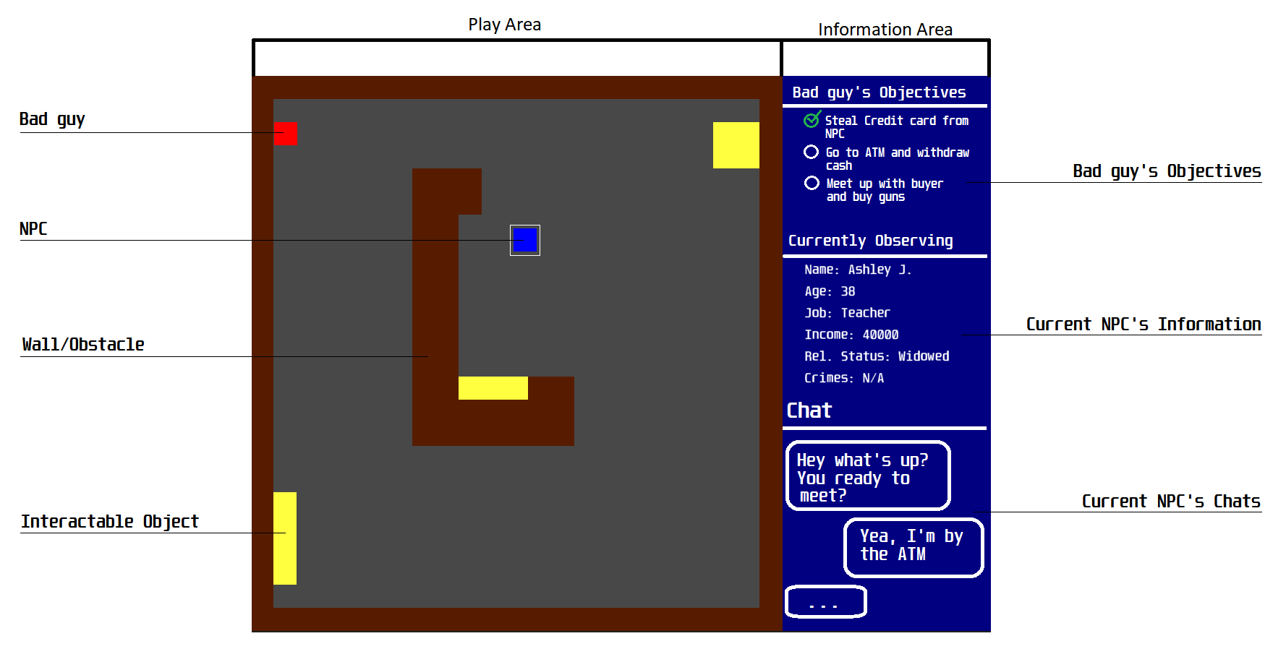The white surrounding the NPC is an indicator to the player that that NPC is the one that is currently being viewed in the information area.

Art Style
The art style of the game will be very simple. Since the game will be a top-down perspective, the detail of some objects will not need to be as great. NPCs and bad guys can be made up of a few circles, for example just the head and a pair of eyes so the player knows which way the NPCs are facing. The obstacles will be a bit more detailed as the NPCs will be interacting with them and the player will need to be able to see what the NPC is interacting with, for example: an NPC withdrawing money from an ATM.

Why the game is fun
The game will give the player a world to explore where they can access information on anyone they see. They can interpret the data on these people any way they would like to and try to determine who is the bad guy.

Design Details

Pillars of Design
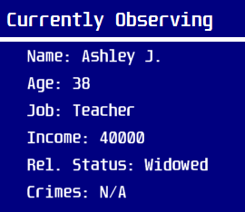
Detail
The player will be able to look at any information about any NPC on screen, as well as any interactable object.
________________________________________________________________________
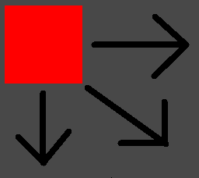
Replayable
The player will be able to replay the levels. The bad guys and NPCs will have a set of random paths they can take for each level, and the bad guys will have a set of random tasks instead of a set number of tasks for each level.
________________________________________________________________________
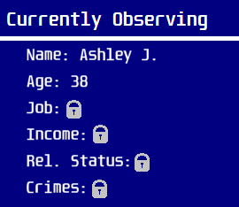
Progression
Thorughout the game, the player and the bad guys will unlock new abilities to either help them determine who the bad guy is, or help them avoid detection of the player.

Characters

The Main Character
The main character is the player. Their job is to watch the NPCs and determine who is a bad guy.

NPCs

NPCs are just characters that are roaming the current level. They serve as a distraction to the player who is looking for the bad guy. They perform random tasks throughout the level.

Bad Guys

Bad guys are the characters that the player is looking out for. They try to complete their list of objectives before the player can catch them.

Story and Setting
The player is a new hire at a company that keeps tabs on people, good and bad. It is the players job to monitor people and figure out who is going to do something bad next. The player will be viewing the city from a computer screen with access to information collected, via some not very legal means, about everyone in the city. Although it is the player’s job to observe, they do not know if it’s the right thing to do since they are invading the privacy of even the most innocent people of the city and seeing them at sometimes their worst moments.

Core Mechanics

Observing
The player’s job is to watch all NPCs on screen determining which one is the bad guy

Time
Each level has a time limit. It is the players job to be as quick as possible to complete a level before the time runs out.

Level Design
Each level will be laid out with multiple NPCs (ranging from 2 to 15), at least 1 bad guy, and multiple interactable objects throughout the level.


Interactive Elements
Most objects in a level will be interactive. The player will be able to click on any NPC or bad guy and see information about said NPC or bad guy, including their name, age, career, or any crimes they have committed.
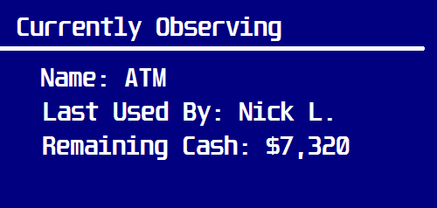
The objects that NPCs and bad guys can interact with are also interactable by the player. The player will be able to click on the objects to see what they are and any other important information the player might want to know about it.

Audio
City noises will be played for background sound, and there will be sounds for clicking on NPCs and objects.

UI Design
The game will have an intuitive design, where the player can click on most objects in a level and have information displayed about that object. The UI will not be intrusive, and it will be easy to understand what is going on.

Bad guys & Behaviours
Bad guys will have a set path throughout a level. They will have a certain amount of actions to perform and there will be several different paths the bad guy can take to complete those actions to add some replayability to the game. Once all the actions of a bad guy are complete, they player loses the level.
Once the player gets to higher levels, the bad guy NPCs will obtain new abilities. They will be able to disrupt the player from seeing information about NPCs or change their information for a few seconds to confuse the player. This will help keep the game more exciting the further the player progresses.

Development Tools & Asset Production
The game will be made using GameMaker Studio Version 1.4. The audio will be created using Audacity and some sound effects will be used from online sources (freesound.org). The assets of the game will be made using GIMP and Microsoft Paint, and some assets will also be used from online sources.
All audio and sprites used from outside sources will be credited in their respective categories in the credits screen.

Game Reception
The game is made to show people just how much information is collected on everyone, even without them knowing. It shows that even a new hire at a company, someone who may not have the best intentions in mind, could have access to such an expansive database of information.

